**Split Implicit Layer**

|  |  |  |
| --- | --- | --- |
| *a class its methods operate at different levels of abstraction* |  | *break up the class in components that each concentrate on a particular level of abstraction* |

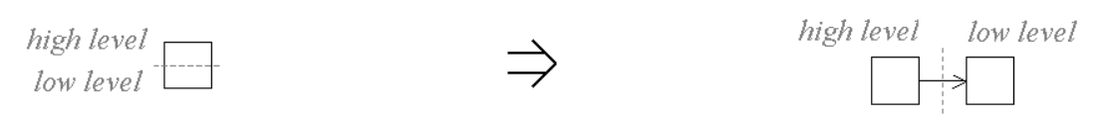

**Context:**  
See also :[Encapsulate Feature](https://web.archive.org/web/20090914101240/http:/www.refactoring.be/thumbnails/rtn-ef.html)